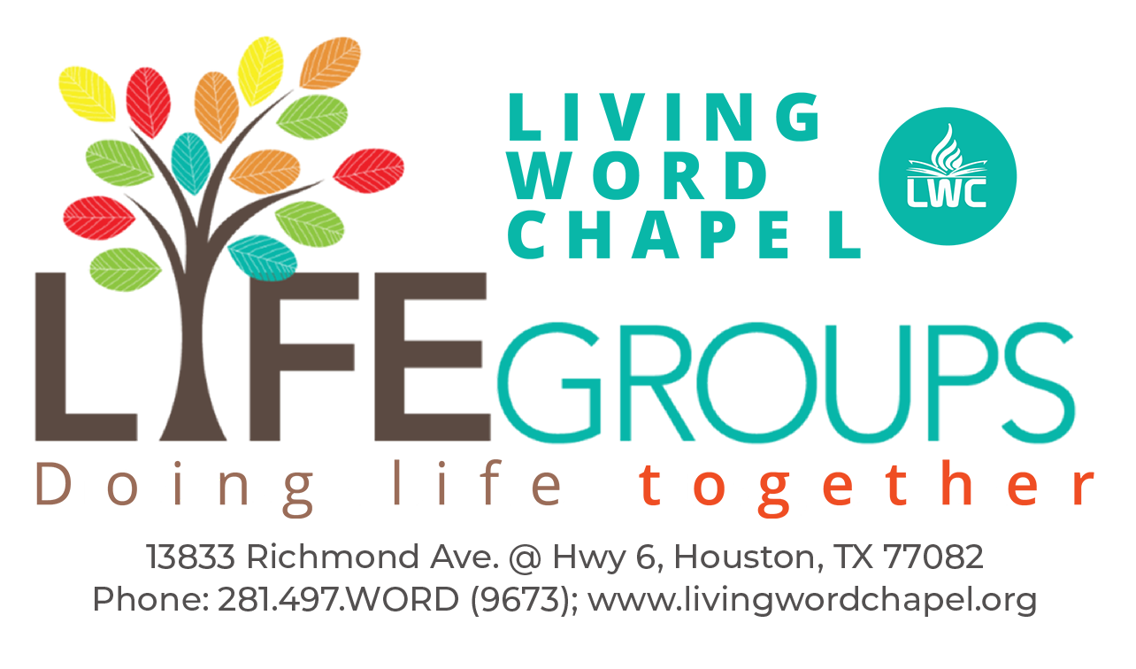  YOU’RE WHAT YOU EAT!  ‘Jennie, your Mom seems way too calm for my comfort. Is she in denial?’ “No, son. I’m not in denial said Jennie’s Mom, Jelda. I’m confident and rested within me. I know who I am. I’m different.”  That’s the conversation that went on between Jennie, her husband, Timmy and her mom, who believes she lives in a bubble and considers herself as special. The question is, why? And the bigger question is, what does she mean when she always says, “eat good food.”  Good food to Jelda is the word you listen to. She’s so full of what God says that she doesn’t even know or hear anything else. And she seldom listens to much television. In her words, ‘you’re what you eat’. Again, she says, faith and fear come by hearing.  If you had lived with us while we were growing up, you would have understood better. We memorized passages like Jos 1:9, “Have I not commanded you? Be strong and of good courage, do not be afraid or dismayed, for the Lord your God is with you wherever you go.” I memorized that at ages 3, 4 and 5. We always recited the stories of five loaves and two fishes feeding five thousand, David killing Goliath, the axhead swimming up, how God rained food from the skies, etc. You never mentioned words like impossible, afraid, worry, confused, etc. in my house,” said Jennie.  “Now I get it, responded Timmy. That’s where you got your courage, confidence, boldness, strength, grit, etc. from. Everyone talked about you as fearless and I believe and see. It’s what you eat. Let’s start feeding our babies quality food as soon as they start talking.” |  | 1. Faith only comes by what you are hearing. This family concentrated only on what will strengthen them, not on their problems. How can you replicate this in your own family?  2. You’re what you eat. Good words matter. Never pray against your problems. Always only pray your solution. That is what Jennie learned and was doing. Discuss.  3. How can you help someone to overcome fear, without ever mentioning fear at all?  1. Declare Jos 1:5 over your life and your family?  2. Prayer is praying the solution, not against the problem. Declare that no weapon can prosper against you and that you will trample down any infirmity and it will not and cannot harm you or your family.  3. From John 14:27, declare the peace of God over all your affairs.  1 OPENING PRAYER 2MIN  2 PRAISE & WORSHIP 5MIN  3 READING MESSAGE OF THE DAY 5MIN  4 TALKING IT OVER 10MIN  5 PRAYING FOR ONE ANOTHER 10MIN  6 CLOSE 3MIN

